Overview:
The standard SHED Model of Care is being altered to reduce the risk of COVID transmission within the department.
This altered Model of Care streams patients based on the COVID risk. COVID risk is identified at Triage, using the Emergency Department COVID risk streaming algorithm (Appendix 1). Patients are designated one of the following COVID risk statuses:
- COVID positive
- High – Risk COVID (Suspected COVID (SCOVID))
  - Symptomology
  - Epidemiological Risk
  - Both
- Low-Risk COVID

The combination of a patient's COVID risk status and Australasian Triage Scale (ATS) category guides the streaming of patients to the most appropriate environment or waiting space in the Sunshine Hospital Emergency Department.
The streaming options for adult patients are detailed in Figure 1: SHED Adult COVID Streaming Model Of Care.
The streaming options for paediatric patients are detailed in Figure 2: SHED Paediatric COVID Streaming Model Of Care.

Principles of the SHED COVID model:
General:
- To improve patient and staff safety through the achievement of better physical distancing and infection prevention protocols.

- COVID and SCOVID patients are placed in clinical or waiting areas where airflow and air exchanges have been increased and maximised.
- Each clinical zone can operate self-sufficiently (medication and consumable storage, access to IT systems, provision of support services) to reduce unnecessary staff movement between zones while creating workflow efficiencies.

Surge Capacity:
- The Nurse in Charge/Floor Coordinator and the Senior Medical Officer in Charge should at any time recommend the flexing of cubicles (within the staffing profile) to the Operations Manager (in-hours) and the After-Hours Administrator (AHA) (out of hours). Any request should be based on a need to meet the current demand profile of the department.

- In the event there is a need to surge above the designated staffing profile this should be escalated to the Operations Manager (in-hours) and the After-Hours Administrator (AHA) (out of hours) – this request should then be escalated to the Divisional Director – Emergency Medicine and Access (in-hours) or the Director-On-Call (out of hour).

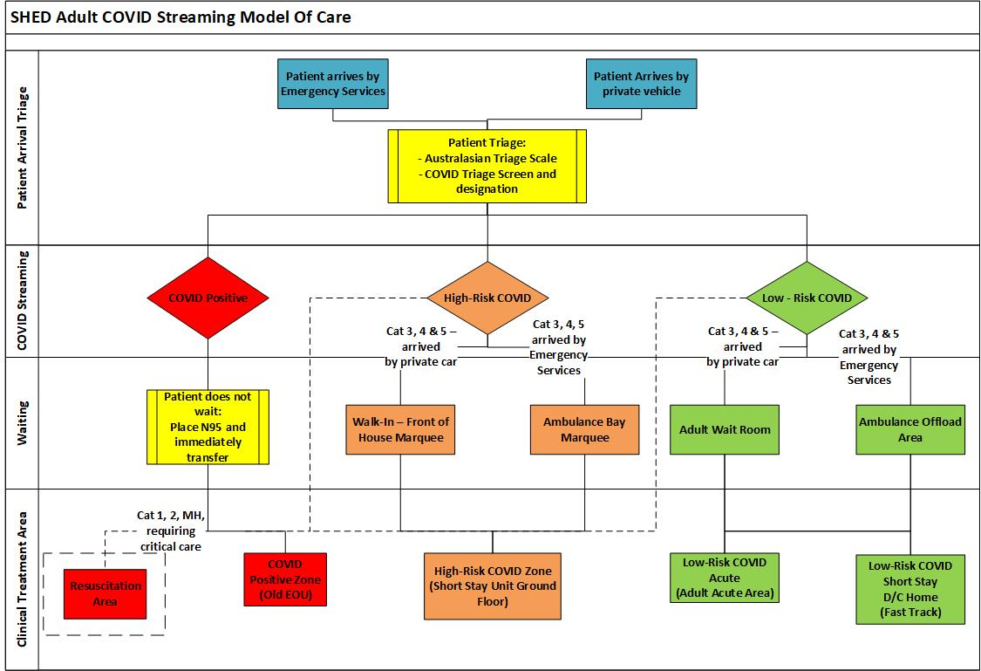
Figure 1: SHED Adult COVID Streaming Model Of Care:

Key Changes to standard SHED Adult MOC:
Patient Arrival, Triage and Waiting Areas:
Arrival by Emergency Services transport:
Patients arriving by Emergency Services transport are to be Triaged between the double doors of the emergency services entrance and the opening of the Ambulance Bay Marquee.
The following should be noted:
- Patients requiring Resuscitation Area level care should be Triaged as per the usual process.

If appropriate, the Triage Nurse should follow the patient to the Resuscitation Area to complete the Triage.

- All confirmed COVID positive patients should be placed in an N95 mask and immediately transferred through the external access doors of the Old EOU.

If a cubicle is available, the patient should be immediately offloaded. If the COVID zone cubicles are all occupied, and the patient is a Category 3, 4 or 5 – without any known contraindications to offload – the patient should be offload into one of the vacant sub-wait areas until a cubicle is free. The Paramedics should be released to return to the community.

- All High-Risk SCOVID patients are to be placed in an N95 mask and either transferred immediately to a High-Risk cubicle/bed or to in the Ambulance Bay waiting area marquee.

- All Low-Risk COVID are to wait in the Ambulance Arrivals area or if appropriate, offload to the Low-Risk wait room should be considered.
Arrival by private car:
- All COVID positive patients should be given an N95 mask and immediately transferred to the COVID zone. If a bed is not available, they should wait in one of the designated sub-wait areas until a bed becomes available.

- All High-Risk SCOVID patients are to be either transferred immediately to a High-Risk cubicle/bed or are to wait in the front of house - external marquee.

- All Low-Risk SCOVID are to wait in the existing Adult Wait Room.

Adult COVID Zones:
The department will operate five clinical zones.
- Resuscitation Zone:

The management of critically unwell patients including those presenting in need of mental health care. COVID & High-Risk COVID should be managed in the negative pressure room or one of the negative flow rooms with the door closed.
Points of Care in operation: 4
Staffing:
- 4 Registered Nurses
- Resus Registrar
- Oversight from the designated resuscitation medical team

Once intubated, a COVID positive of High-Risk SCOVID patient can be managed in the open door Resuscitation Bay – (Resus 2)
Supporting Documentation:
Use of Adult Acute Assessment Treatment Room, Negative Air Flow and Negative Pressure Rooms - SHED
- COVID Positive Zone (Old EOU):

All patients streamed as COVID positive who do not need Resuscitation level care are to wait or be treated in this area.

Points of Care in operation: 6 Cubicles and 3 sub-wait areas

Staffing:
- 2 Registered Nurses
- 1 Health Care Worker – PCA
- Green Medical Team

If a patient requires high flow oxygen or non-invasive ventilation, but is not for the Resuscitation Area they are to be managed in Negative Pressure Room 23 or Negative Pressure Room – SSU 1.

- High – Risk COVID Zone – Short Stay Unit
All patients who are designated as High-Risk COVID not needing resuscitation level care are to be cared for in this area.
Points of Care in operation: 12

Staffing:
- 4 Registered Nurses
- Green Medical Team

- Low-Risk COVID Acute Zone (Adult Acute)

All patients who are Low-Risk COVID, not for Resuscitation level care, but are significantly unwell and are likely to need an admission.

Points of Care in operation: 12

Staffing:
- 4 registered Nurses
- Yellow Medical Team

- Low-Risk COVID Short Stay D/C home Zone (Fast Track Level 1)

All patients who are are designated Low-Risk COVID but have an illness that is unlikely to need admission to an acute inpatient bed after a period of observation or clinical intervention.

Points of Care in operation: 16

Staffing:
- Short Stay Unit Nurse In Charge
- 4 Registered Nurses
- Short Stay Unit Medical Team
Supporting Documentation:
Short Stay unit – Clinical Practice Guidelines
Sunshine Hospital Emergency Department – Model of Care Guideline – Emergency Department Obstetrics and Gynaecology Registrar

Sunshine Hospital Emergency Department – Adult Fast Track Clinical Practice Guideline

Key Changes to Paediatric Model of Care:
Patient Arrival, Triage and Waiting Areas:
Arrival by Emergency Services transport:
Patients arriving by Emergency Services are to be Triaged between the double doors of the emergency services entrance and the opening of the Ambulance Bay marquee.
The following should be noted:
- Patients requiring Resuscitation Area level care should be Triaged in the normal way.

If appropriate, the Triage Nurse should follow the patient to the Resuscitation Area to complete the Triage.

- All confirmed COVID positive patients should be placed in an N95 mask and immediately transferred to the Paediatric pod to be offloaded into the appropriate clinical space or wait in a single closed-door room.

- All High-Risk SCOVID patients are to be placed in an N95 mask and either transferred immediately to a High-Risk Paediatric cubicle or wait in an empty Paediatric closed-door single room.

- All Low-Risk SCOVID are to wait in the Ambulance Arrivals area or, if appropriate, offload to the Low-Risk Paedirtric wait room should be considered.

Arrival by private car:
- All COVID positive patients should be given an N95 mask and immediately transferred through to the Paediatric pod to be offloaded into the appropriate clinical space or to wait in a close door single room.

- All High-Risk SCOVID patients are to be placed in an N95 mask, either transferred immediately to a High-Risk cubicle/bed or are to wait in the existing Paediatric wait room (now classified as the Paediatric High-Risk Wait room)

- All Low-Risk SCOVID are to in the Fast Track area of the paediatric pod that has been set up as an internal sub-wait.

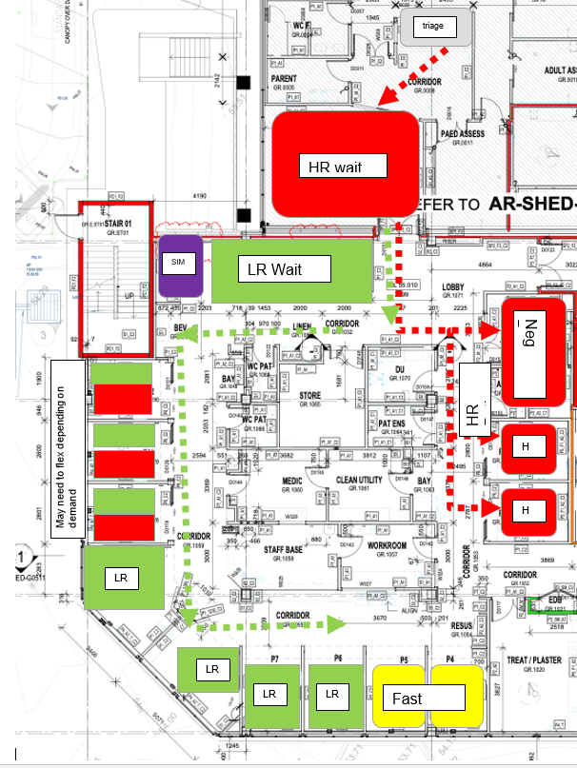
Figure 2: SHED Paediatric COVID Streaming Model Of Care

COVID Screening and Testing:
The following COVID screening and testing process should be applied to all patients who attend a Western Health Emergency Department (Figure 3):
Step 1 - Initial Screening at Triage:
All patients should be designated as either, COVID positive, High-Risk COVID, or Low-Risk COVID at Triage – and this information should be detailed in the Presenting Problem/Diagnosis section of the Emergency Department information System.
Step 2 – EMR Initial Screening Tool:
The EMR initial screening tool should be completed by the designated Front of House healthcare workers within 30 minutes of the patient arriving.
If a patient is immediately transferred to an available cubicle then the screening tool should be completed by the treating medical officer.
Step 3: Rapid Antigen Test (Appendix 2):
All High and Low-Risk COVID patients should have a Rapid Antigen COVID test completed within thirty minutes of arriving. The result should not delay the transfer of a patient to a designated zone based on the initial Triage COVID screen.
If the patient is in a waiting area, the designated Front of House healthcare workers will complete the Rapid Antigen testing.
If a patient is immediately transferred to an available cubicle then the Rapid Antigen Test should be completed by the allocated cubicle/bedside Nurse.
Step 4: COVID PCR
If the patient returns a positive Rapid Antigen test or was screened at Triage as High-Risk a COVID PCR swab should be organised.

Figure 3: Western Health Emergency Department COVID Screening and Testing
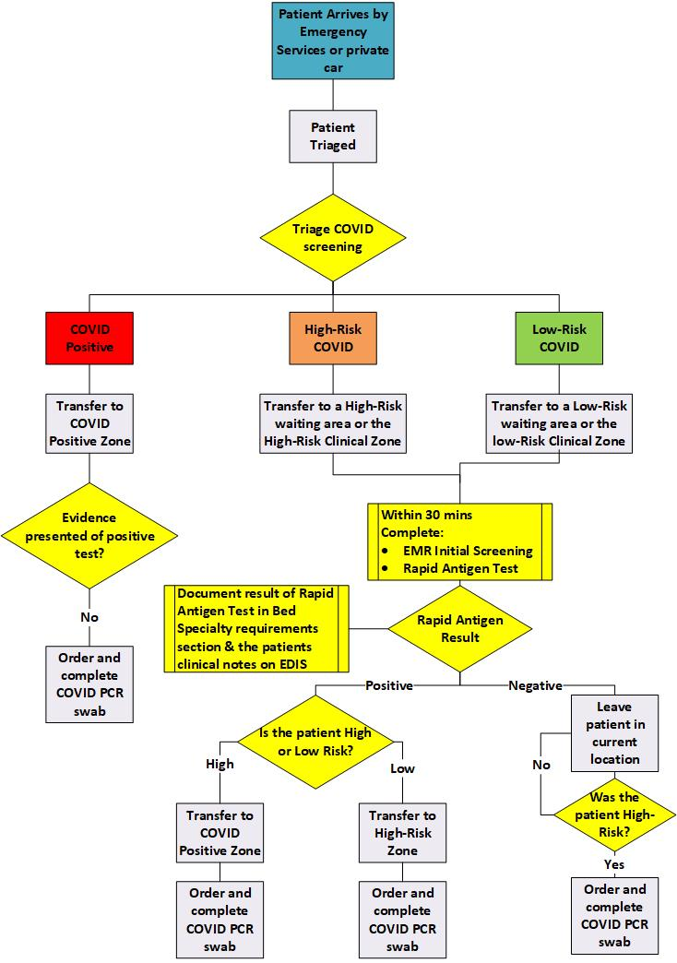

Sunshine Hospital Emergency Department Surge Capacity:
Area/Zone | Surge Capacity | Specific Requirements
Front Of House | - Addition of High- Risk Adult Wait Room Marquee  - Addition of High- Risk Adult Ambulance Offload Marquee  - Conversion of Paediatric Fast Track Area into Low Risk waiting room  - Three Triage Assessment Cubicles overnight | - Two additional wait room Nurses per-shift  - Four additional health care workers per-shift to complete COVID screening and Rapid Antigen testing.  - Additional security to support the operations of the external marquees  - Additional PSA's to support the cleaning of the external marquees  - One Register Nurse for night duty
Resuscitation Area | - Four additional Resuscitation Bays (Old Resus)  - Negative Pressure Rooms | - Four Nurses with Critical Care certificates.  - Two Nurse working toward a critical care certificate
COVID Zone | - Three additional cubicles | - One registered Nurse
High-Risk Zone | - Nine additional clinical spaces | - Three registered Nurses  - 30 McMonty hoods
Low Risk - Acute | - Nine additional cubicles | - Three registered Nurses
Paediatric Area | - Three additional cubicles | - One registered Nurse
Low-Risk – Short Stay | N/A | N/A

Appendix 1:
Figure 1: Emergency Medicine COVID 19 COVID Positive, High Risk and Low Risk sorting Algorithm
